European Semester 2015/2016 country fiche on disability
Luxembourg | 
Report prepared by: Arthur Limbach-Reich
With comparative data provided by the ANED core team

The Academic Network of European Disability experts (ANED) was established by the European Commission in 2008 to provide scientific support and advice for its disability policy Unit. In particular, the activities of the Network support the development of the European Disability Strategy 2010-2020 and practical implementation of the United Nations Convention on the Rights of Disabled People in the EU.

This country report has been prepared as input for the European Semester from a disability perspective.

Note:
The statistics provided in October 2015 are based on the EU-SILC 2013. This is the most recent microdata available to researchers for analysis from Eurostat. This report may be updated as new data becomes available.



Table of contents

1 Summary of the overall situation and challenges 2
2 Assessment of the situation of disabled people with respect to the Europe 2020 headline targets 3
2.1 Strategic targets 3
2.1.1 A note on the use of EU data 4
2.2 Employment data 5
2.2.1 Unemployment 12
2.2.2 Economic activity 15
2.3 Education data 18
2.3.1 Early school leavers 18
2.3.2 Tertiary education 21
2.4 Poverty and social exclusion data 24
3 Description of the situation and trends in relation to each target area 28
3.1 Employment 28
3.2 Education 29
3.3 Poverty and social inclusion 30
4 Assessment of policies in place to meet the relevant headline targets 32
4.1 Employment 32
4.2 Education 34
4.3 Poverty and social inclusion 35
4.4 Synergies between developments in the different areas 37
5 Review of the European Semester from a disability perspective 38
5.1 Progress on disability-specific Country Specific Recommendations (CSRs) 38
5.2 Progress on other CSRs from a disability perspective 38
5.3 Assessment of disability issues in the Country Report (CR) 38
6 Assessment of the structural funds ESIF 2014-2020 or other relevant funds in relation to disability challenges 40
7 Recommendations 42

Summary of the overall situation and challenges

While overcoming the global financial crisis the economic situation remains relatively favourable in Luxembourg and forecasts call for a re-acceleration of economic growth in upcoming years. Unemployment rates are already re-declining.

From a disability perspective the situation in Luxembourg is difficult to summarise, as there are opposing tendencies and developments existing at the same time. Employment of persons with disabilities is split into two systems: the main labour market and sheltered employment. Recently the number of persons with disabilities guided to sheltered workshops has slightly decreased and the number of disabled workers guided to the main labour market increased. Unemployment is much more frequent among disabled persons than among non-disabled persons. In particular the group of persons with severe handicaps are frequently without employment and are looked after in day care centres. There is a challenge to ensure that existing national acts on employing persons with disabilities are respected by private and public employers. Transitions from sheltered workshops to main labour market are not systematically registered or analysed, but seem to be very low. On the other hand the move from special educational units to sheltered workshops is a general phenomenon that hinders from the very start the inclusion in the first labour market.
Educational inclusion and the CRPD are well accepted as a principal or guiding concept. Educational efforts have been made to minimize early school leaving and to include pupils with special needs in the regular school system. But very recently the dropout rates are rising again. Disability in this context often is perceived to refer to a slow learner or a student with disabilities who does not need pervasive assistance and support in educational programme or didactic strategies. The recently adopted Act on primary school introduced a learning outcome based evaluation and assessment sheet by which the decision is made if the pupil progresses to the next level or not. This is scarcely compatible with the principle of inclusion for all. Despite priority on inclusion the number of pupils in special educational units rises. Maybe that is due to the decline of pupils and students with disabilities educated outside Luxembourg.

Concerning higher education the target of 66% is still not reached. In 2013 the national quota reached 42.8%. This is slightly above the EU average 40% but an important gap compared with the national 2020 target. At the one and only national University the quota of students with disabilities is below 1%. There are still a lot of efforts to do in rising participation in higher education by including students with disabilities.

The risk of poverty and social exclusion is higher in households with a disabled person and with low work intensity. Low educational attainment, low work intensity and high risk of poverty occur together in disability related households. In general the overall population at risk of poverty or social exclusion recently rises and still disability is an important factor linked to the risk of poverty.

Assessment of the situation of disabled people with respect to the Europe 2020 headline targets

Strategic targets

Table 1: Europe 2020 and agreed national targets for the general population
 | Europe 2020 targets | National targets
Employment | 75% of the 20-64 year-olds to be employed | 73%
Education | Reducing the rates of early school leaving below 10% | <10%
Education | At least 40% of 30-34–year-olds completing third level education | 66%
Fighting poverty and social exclusion | At least 20 million fewer people in or at risk of poverty and social exclusion | Reduce by 6 000 the number of people living in  poverty or social exclusion (compared to 2008)

Relevant disability targets from national strategies or sources:

The NRP sets an intermediate target on employment by aspirating an employment rate for women and men aged 20-64 at 71.5% in 2015.

Focussing on disabled workers, the NRP formulates additional targets on accessing employment and integration into the primary labour market for such persons, as well as providing protected structures for those people, but the NRP does not specify a definite number or percent value.

Without indicating time frames the NRP insists on reducing sustainably the rates of early school leaving below 10%. In relation to higher education the NRP indicates that this target should be regarded under the particularly background of high immigration rates and non-native students in Luxembourg.

While the French (“pas d’ objectif”) and German (“kein Ziel”) overview of Europe 2020 targets do not specify any concrete objective on the reduction of population at risk of poverty or social exclusion (in number of persons), there is such an issue mentioned in the English table as stated above. Also the genuine NRP highlights that Luxembourg aims to reduce the number of persons under the threat of poverty or social exclusion by 6,000 people by 2020.

A note on the use of EU data

Unless specified, the summary statistics presented in this report are drawn from 2013 EU-SILC micro data. The EU-SILC sample includes people living in private households and does not include people living in institutions. The proxy used to identify people with disabilities (impairments) is whether ‘for at least the past 6 months’ the respondent reports that they have been ‘limited because of a health problem in activities people usually do’. Responses to this question vary between countries and national data sources are added for comparison, where available.
Table 2: Self-reported ‘activity limitations’ as a proxy for impairment/disability (EU-SILC 2013)
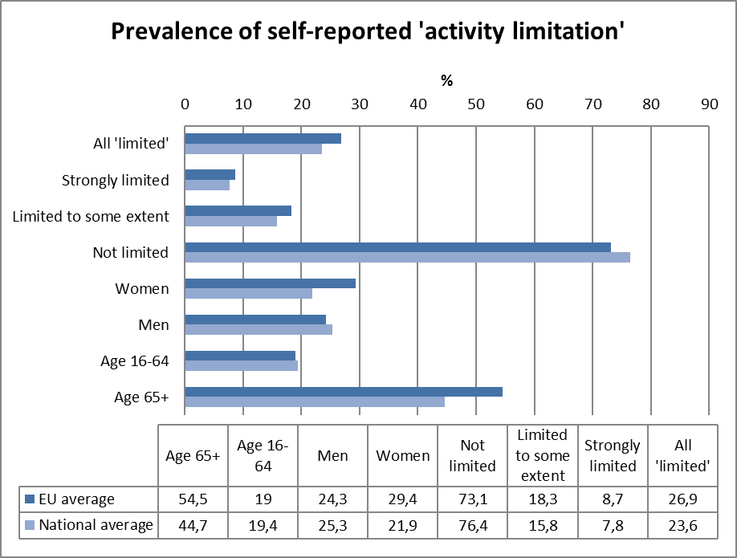
Source: EUSILC UDB 2013 – version 2 of August 2015
It is relevant to observe that Luxembourg’s estimates of impairment prevalence fall below the EU average for older people, which may affect estimations of equality gaps.

In subsequent tables, these data are used as a proxy to estimate ‘disability’ equality in the main target areas for EU2020 – employment, education and poverty risk. The tables are presented by disaggregating the estimated proportion of people who report and do not report limitations for each indicator (e.g. among those who are employed, unemployed, at risk of poverty, etc.).

Employment data

Table 3: Most recent employment data, aged 20-64
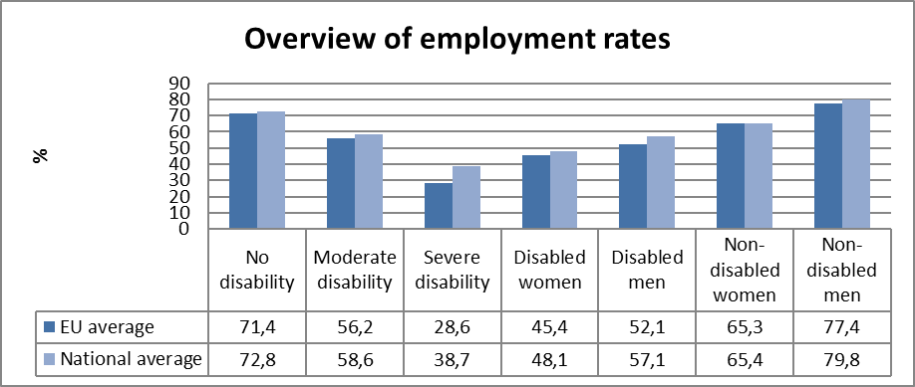
Source: EUSILC UDB 2013 – version 2 of August 2015

Table 4: Employment rate data, by age group
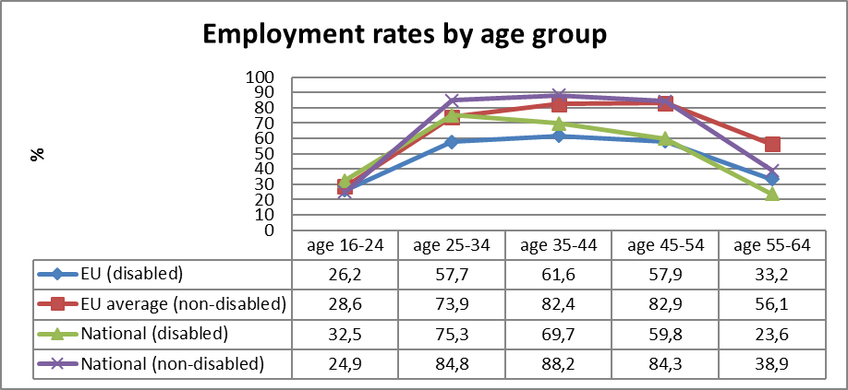
Source: EUSILC UDB 2013 – version 2 of August 2015
Table 5: Trends in employment by gender and disability (aged 20-64)
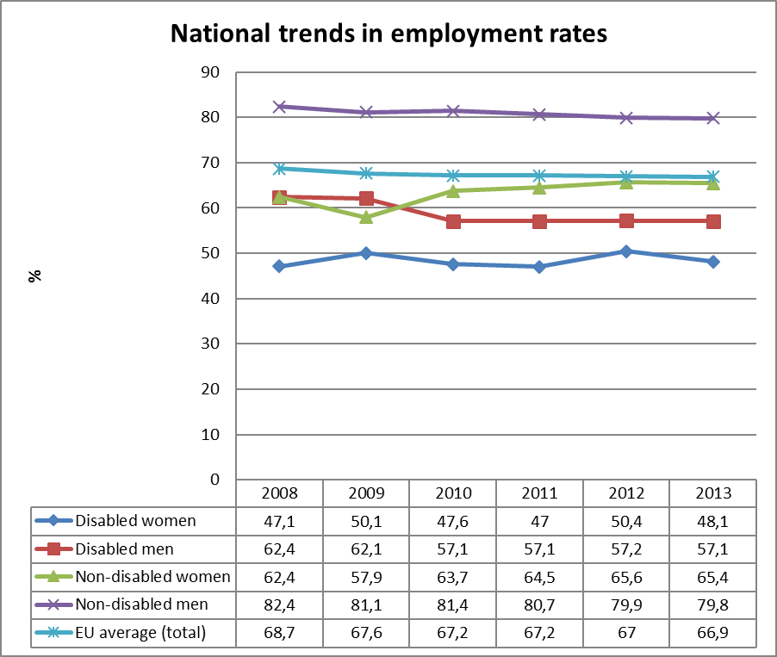
Source: EUSILC UDB 2013 – version 2 of August 2015 (and preceding UDBs)

The table above shows a comparison of national employment trends for disabled and non-disabled women and men, and compares this with the EU2020 headline indicator for the EU as a whole.

Alternative data on disability and employment provided by the national expert:

In 2012 the national Institute for statistics and economic studies STATEC (L’Institut national de la statistique et des études économiques) published some data about economic activity and disability in Luxembourg. Following these statistics, among working people aged between 15 to 64 years, 14% reported suffering from a health problem that limited or reduced their capacity to work. There is a total of approximately 48,000 workers whose professional activity is restricted by their state of health. It is 6% for younger people (15-24), 8% in age group 25-34 years and 12% in the 35 to 44 year age class. Those who were 45 to 54 years old reached 20% and among persons aged 55 to 64 years, 25% have a disability. Regardless of age, women have higher rates of disability than men. In total the rate is 17% for women and 11% for men. In 2014 the COR (a special unit on assigning persons with impairments or reduced working capacities - “Commission d’orientation et de reclassement professionnel”) at the national Employment Development Agency (ADEM) recognized 426 persons (on the basis of 863 requests i.e. 49% acceptance) as disabled worker (salarié handicapé). Over the last five years (2010 to 2014) the number of demands for recognition as a disabled worker (salarié handicapé) declines while the number of recognitions rises at the same time.

Disabled worker: Requests and Recognitions 2010-2014
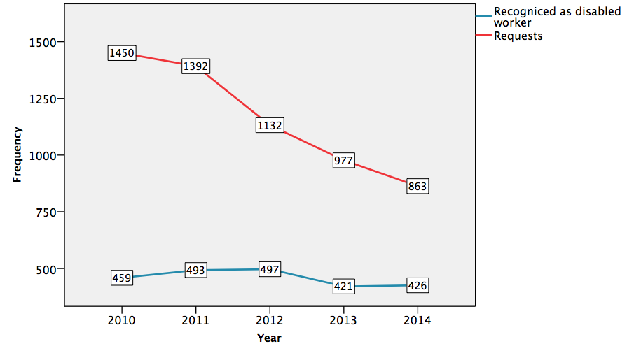
On the other hand the percentage of positive approvals is almost continuously rising.
Percent of Recognitions as “disabled worker” 2010-2014
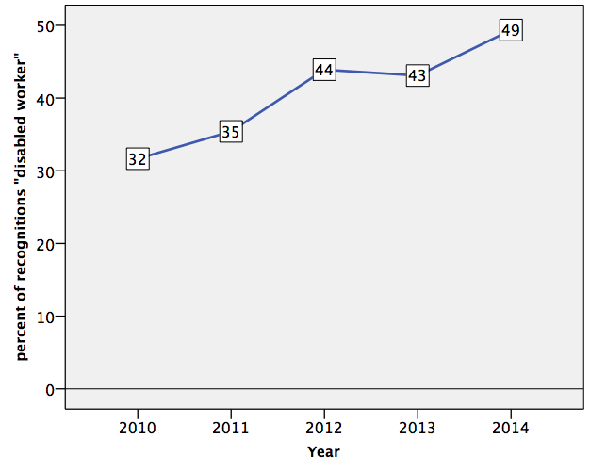
Rate of working people suffering from a health problem or disability in Luxembourg 2012
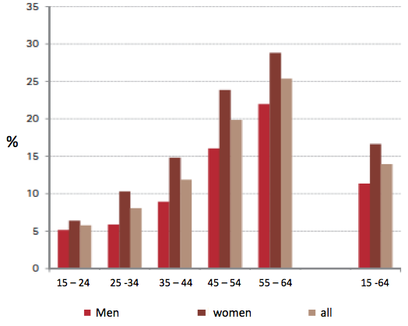
All workers with health problems | 6% | 8% | 12% | 20% | 25% | 11% (male) 17%(female)
Age group | 15-24 | 25-34 | 35-44 | 45-54 | 55-64 | all ages15-64

Source: Bintener, Chr. (MIFA/SNAS), Bourgeois, N. (Inter-Actions), Frising, A. Osier, G. Reiff, P. Ries, J. Zahlen, P. (STATEC) 2012 Rapport travail et cohésion sociale cahier économique N° 114, p.90.

The national Agency for employment (ADEM) in 2013 counted 4,042 disabled job seekers or job seekers with a reduced work capacity (21% of all jobseekers).

For disabled workers a special unit on assigning persons with impairments or reduced working capacities COR (“Commission d’orientation et de reclassement professionnel”) at the national Employment Development Agency (ADEM) advises persons with disabilities about the mainstream labour market or sheltered workshops. The Ministry of Labour publishes every year a national report on trends and facts on the labour market and unemployment. From 2010 till 2013 the following data and developments are visible:

Figure 1: Developments in orientation towards labour market and sheltered workshop for disabled workers
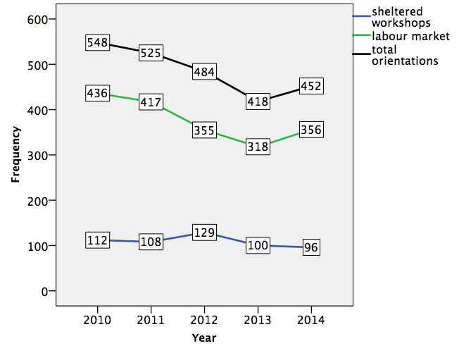
Source: Ministry of Labour (yearly reports 2010 – 2014)

These data reveal that since the ratification of the CRPD by the Luxembourgish Gouvernement (2011) the number of orientations by the national Employment Agency (ADEM) for disabled worker decreases but rebounds in 2014. While the number of advices towards sheltered workshops weakens, the frequencies of advices to the main labour market reached a low point in 2013 and run up again in 2014.

There is a disproportion of orientation in function of age: the highes risk of being orientated towards sheltered workshops is in the first age group (age less than 26)

Figure 2: Orientation towards labour market and sheltered workshop for disabled workers by age
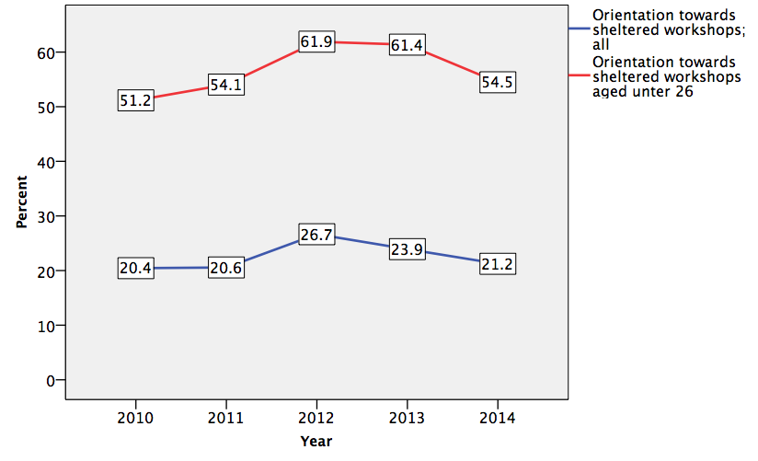
Source: Ministry of Labour (yearly reports 2010 – 2014)

The overall probability for young persons recognized as disabled workers (aged 18 to 26) being oriented towards sheltered workshops is more than twice that for all other age groups. This result can be explained by the fact that in Luxembourg students with disabilities preponderantly continue after primary and secondary education by starting a vocational training programme in special training centers for people with disabilities (CPP: Centre de propédeutique professionnelle). At age 18 the approval as disabled worker can be awarded, and most of the students switch from the CPP to sheltered workshops.

Unemployment

National administrative rules and definitions of ‘unemployment’ vary, and these may affect the way in which disabled people are categorised in different countries. The following tables compare national data with the EU2020 headline indicator for the EU.

Table 6: Most recent unemployment data, aged 20-64
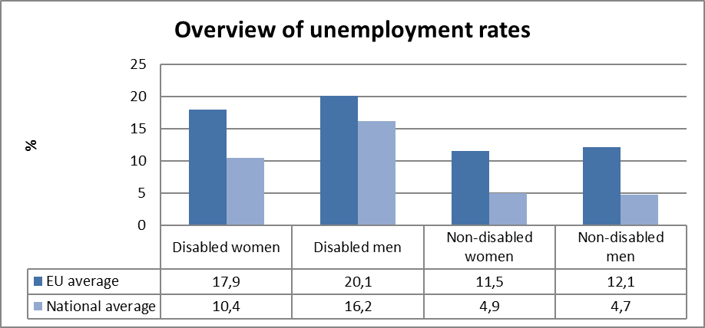
Source: EUSILC UDB 2013 – version 2 of August 2015

Table 7: Unemployment rate data, by age group
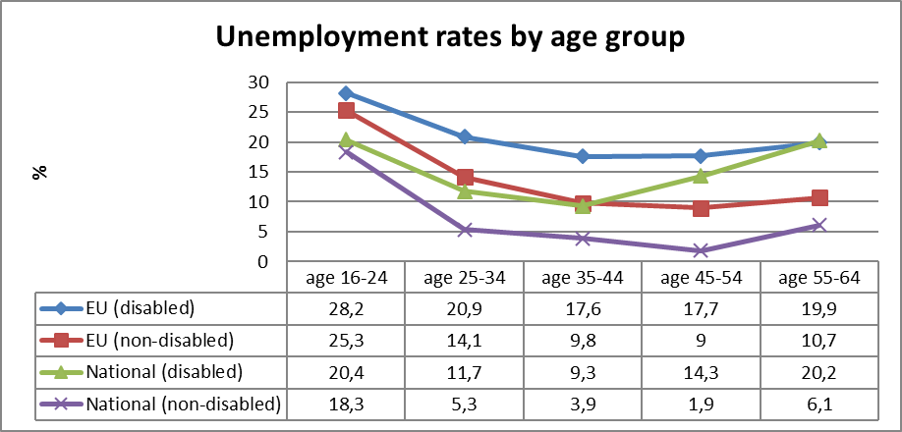
Source: EUSILC UDB 2013 – version 2 of August 2015

Table 8: Trends in unemployment by gender and disability (aged 20-64)
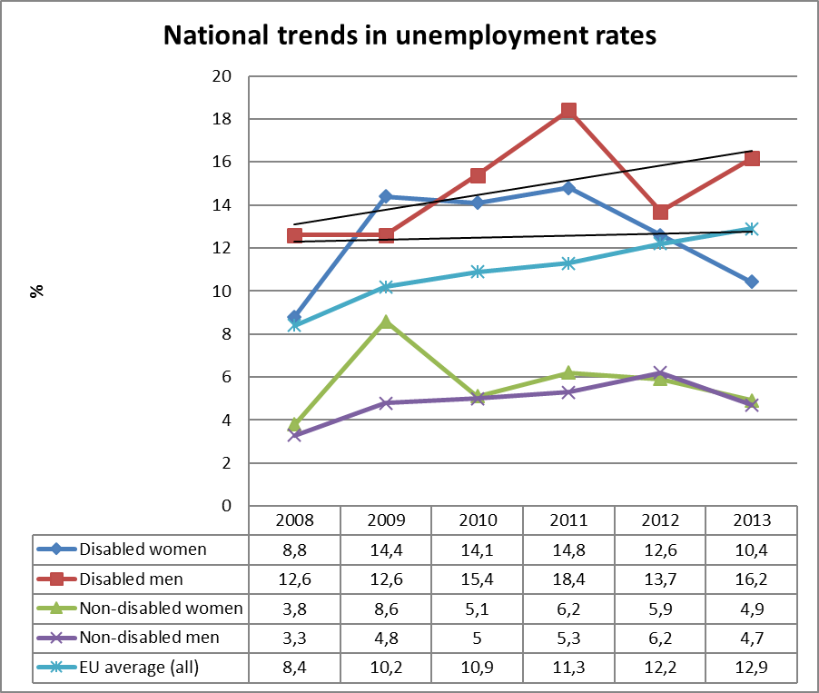
Source: EUSILC UDB 2013 – version 2 of August 2015 (and preceding UDBs)
Fluctuations in gendered trends of unemployment for people with impairments at national level should be treated with some caution. Trend lines for disabled women and men are added here purely for illustration but they should be treated with caution.

Alternative data on disability and unemployment from national sources:

The National Institute of Statistics and Economic Studies (STATEC) of the Grand Duchy of Luxembourg does not release particular data about employment / unemployment of persons with disabilities. Unemployment rate (in %) - seasonnally adjusted in general was indicated by 6.9 in August 2015 (the most recent data). The labour union office for worker with disabilities (OBGL salarié handicapé) estimates the unemployment for disabled worker is 30% higher that for non-disabled worker. On this basis the unemployment quota for disabled worker can be assumed at 9.6%. Looking on the proportion of unemployed worker within all unemployed persons the ratio is quite stable the last five years:

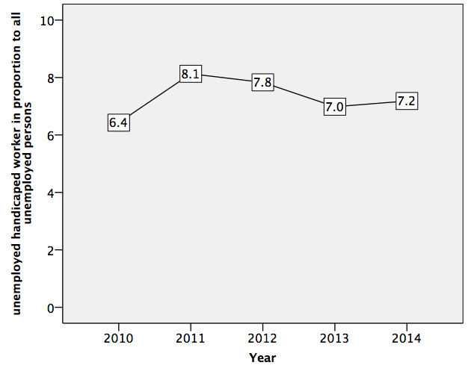
The population of unemployed worker with disabilities (average of the year) rises in the same time from 870 in 2010 to 1315 in 2014.

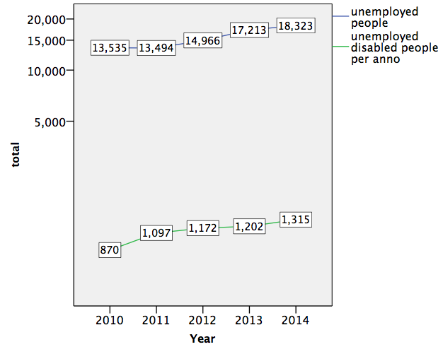
While the general population of unemployed persons rises by 31,8% (from 13535 up to 18323) the population of unemployed worker with disabilities rises by 51,3% (from 870 up to 1315). In other words for disabled worker the slope of unemployment was steeper than for non-disabled worker.

Economic activity

Table 9: Most recent economic activty data, aged 20-64
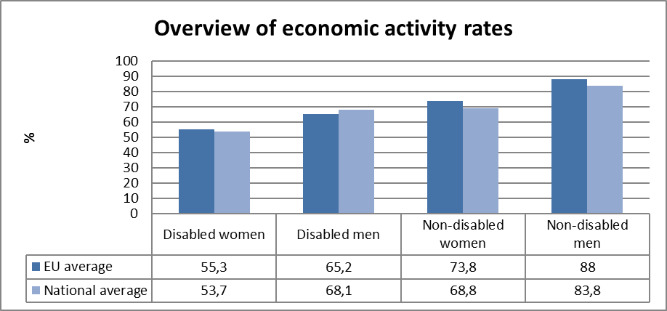
Source: EUSILC UDB 2013 – version 2 of August 2015

Table 10: Activity rate data, by age group
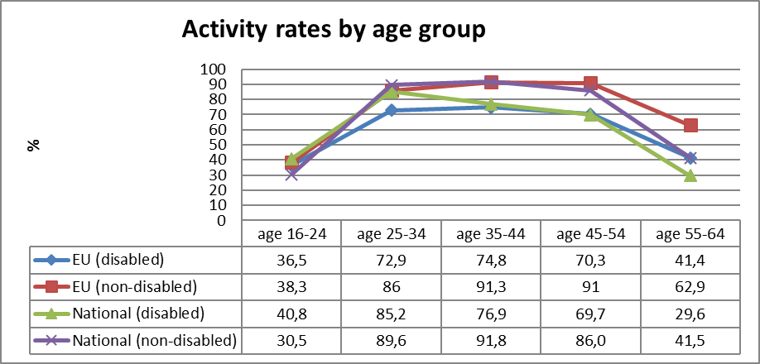
Source: EUSILC UDB 2013 – version 2 of August 2015
Table 11: Trends in activity rates by gender and disability (aged 20-64)
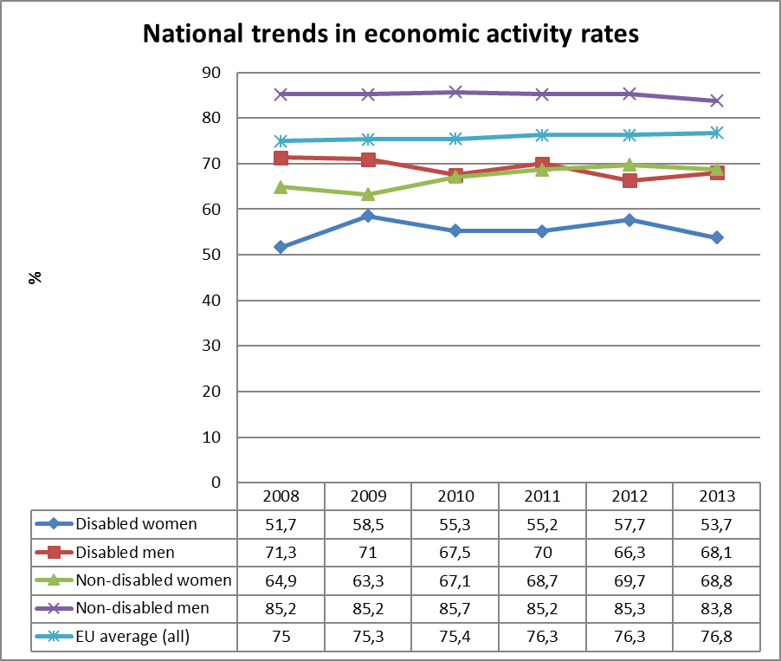
Source: EUSILC UDB 2013 – version 2 of August 2015 (and preceding UDBs)

Alternative data on disability and economic activity provided by the national expert:

The National Institute of Statistics and Economic Studies (STATEC) of the Grand Duchy of Luxembourg indicates no disability related data about economic activity. On the basis of the yearly reports of the National Employment Office (ADEM) some data can be compiled:

The frequency of unemployed person enrolled at the National Employment office (ADEM) at the end of the year is still rising: These data differ slightly from the yearly average data above.
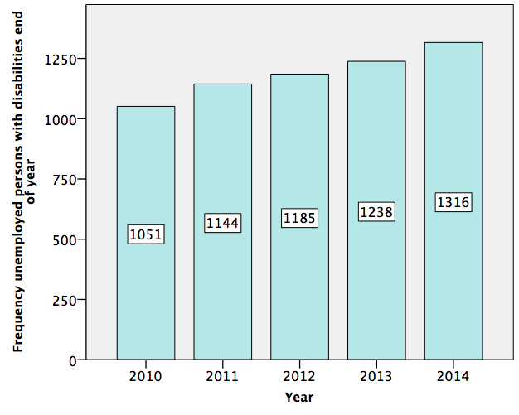
While the frequency of unemployed disabled worker rises the frequency of annual new recognitions of persons as disabled worker decreases.

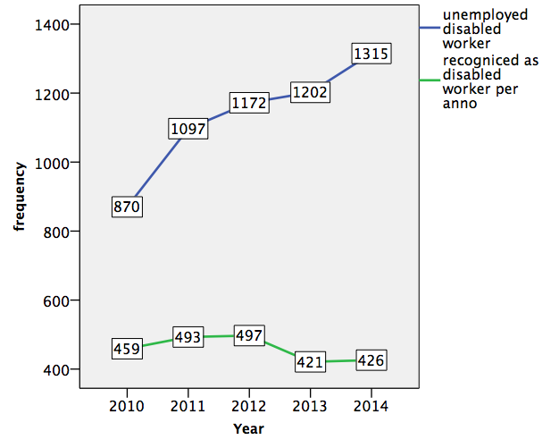
These data indicate (all other things being equal), that the population of persons with disabilities who are economic active is decreasing the last two years.

Education data

EU statistical comparisons are more limited concerning the education of young disabled women and men in the EU2020 target age groups. Data is available from EU-SILC (annually) as well as the Eurostat Labour Force Survey ad-hoc disability module (for 2011), but with low reliability for several countries on the key measures. Using a wider age range can improve reliability but estimations by gender remain indicative. EU trends are evident but administrative data may offer more reliable alternatives to identify national trends, where available.

Early school leavers

The EU-SILC sample for the target age group (aged 18-24) includes the following number of people reporting activity ‘limitation’ (as a proxy for impairment/disability).

Table 12: EU-SILC sample size in the target age group 18-24 versus 18-29
 | Age 18-24 |  | Age 18-29
 | No activity ‘limitation’ | Activity ‘limitation’ | No activity ‘limitation’ | Activity ‘limitation’
EU sample | 34,413 | 2,728 | 56,461 | 4,916
National sample | 854 | 72 | 1,274 | 121
Source: EUSILC UDB 2013 – version 2 of August 2015

Table 13: Early school leavers aged 18-24 (indicative based on above sample size)
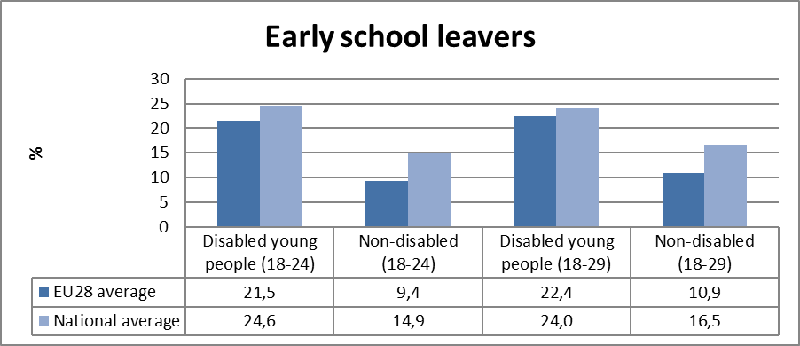
Source: EUSILC UDB 2013 – version 2 of August 2015

Alternative data on disability and early school leavers provided by the national expert:

The Luxembourg Ministry for Education Childhhood and youth estimates that 11.6 % of the cohort 2012/2013 (all school leavers) leave school early (taux de décrochage théorique).

Year | percent
2009/2010 | 9.0
2010/2011 | 9.0
2011/2012 | 9.2
2012/2013 | 11.6

These data differ from the above mentioned EUSILC UDB 2013 data. More recent data are not available.

Children with special needs included in mainstream education benefit from special assistance within primary school in relation to class (cycle).
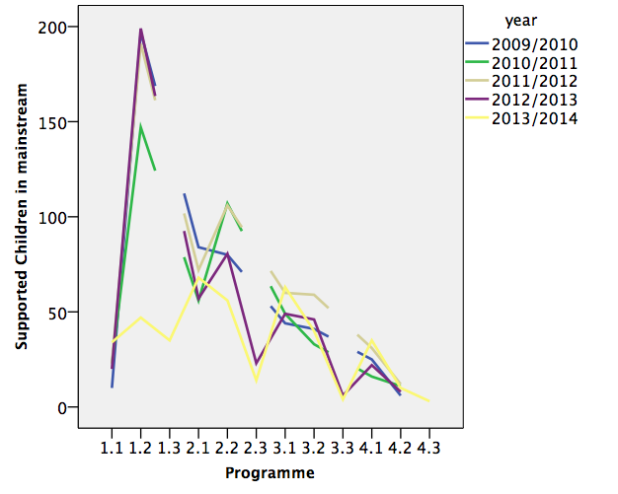
The further the school years advances from cycle 1 up to cycle 4 the less children receive assistance or special educative support. This decline of support may be explained by the sustainable effect of prior support or by the increasing dropout of children with learning disabilities. The available data do not allowed to answer this question.

More recent data about schooling of children with disabilities are compiled in the following table:

Year | Primary school | Special Education | F | M | Non Lux | Ex-clusion | Outside Lux | Out side % | In-cluded
2009/10 | 46443 | 608 | 210 | 398 | 50,8 | 1,3 | 169 | 21,8 | 487
2010/11 | 46152 | 690 | 231 | 459 | 51,3 | 1,5 | 165 | 19,3 | 442
2011/12 | 46858 | 779 | 278 | 501 | 60,8 | 1,6 | 154 | 16,5 | 554
2012/13 | 46856 | 848 | 281 | 567 | 51,3 | 1,8 | 124 | 12,8 | 496
2013/14 | 46859 | 835 | 275 | 560 | 51,4 | 1,8 | 118 | 12,4 | 630

In the last five years the number of children with special educational needs educated outside of Luxembourg declined. The number of children educated in separated units recently decreased after a long period of continuously increasing numbers. The number of students included in mainstream classes rises and the percentage of Inclusion oscillates within 37% and 45%.

Tertiary education

The EU-SILC sample for the target age group (aged 30-34) includes the following number of people reporting activity ‘limitation’ (a proxy for impairment/disability) although the number of missing observations is larger than the number of observations for activity limitation.

Table 14: EU-SILC sample size for the target age group 30-34 versus 30-39
 | Age 30-34 |  | Age 30-39
 | No activity ‘limitation’ | Activity ‘limitation’ | No activity ‘limitation’ | Activity ‘limitation’
EU sample | 23,851 | 2,866 | 50,496 | 6,732
National sample | 586 | 83 | 1,206 | 182
Source: EUSILC UDB 2013 – version 2 of August 2015

Table 15: Completion of tertiary or equivalent education (indicative based on above sample)
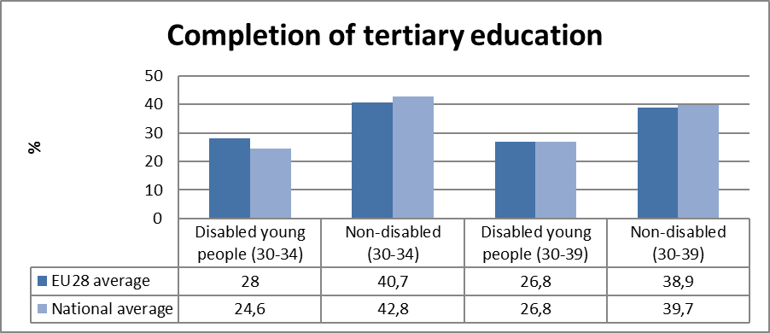
Source: EUSILC UDB 2013 – version 2 of August 2015

The survey sample is not sufficient to provide robust trend data disaggregated by gender in the narrow EU2020 target age group. In only 11 out of 28 Member States are there more than 50 observations in the sample for both women and for men in aged 30-34 who also declare impairment/limitation.

The following table is indicative at the EU level but gender trends at the national level should be treated with caution. In all Member States except Austria the achievement of tertiary education was higher for women than for men in both groups.

Table 16: Trends in tertiary education by disability (aged 30-34)
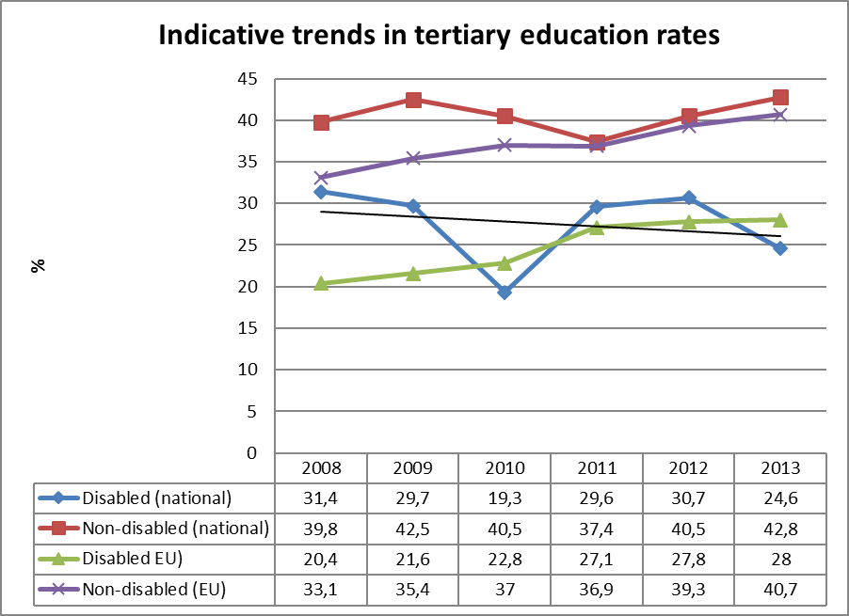
Source: EUSILC UDB 2013 – version 2 of August 2015 (and preceding UDBs)
Fluctuations in the trend for people with impairments at national level should be treated with caution. A trend line is added purely for illustration but should be treated with caution.

Alternative data on disability and tertiary education provided by the national expert:

At Luxembourg University less than one percent of the students indicate a disability or illness at the enrolment procedure. The quota remains below the one percent level the last five years (2010 – 2015).
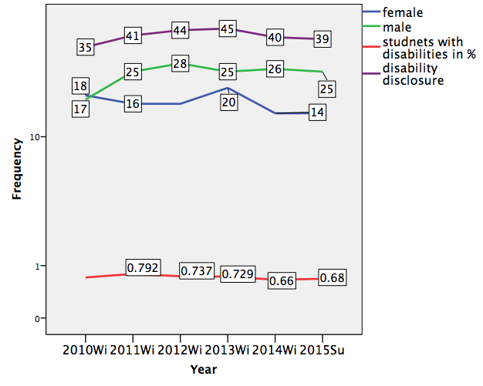

Poverty and social exclusion data

EU SILC data provides indicators of the key risks for people with disabilities. In addition to household risks of low work intensity, there are risks of low income (after social transfers), and material deprivation. These three measures are combined in the overall estimate of risk. The risks for older people do not include work intensity (Eurostat refers to the age group 0-59 for this measure). The survey does not distinguish ‘activity limitation’ (the proxy for impairment/disability) for children under the age of 16. Relevant data provided by the national expert is added where available.

Table 17: People living in household poverty and exclusion by disability and risk (aged 16-59)
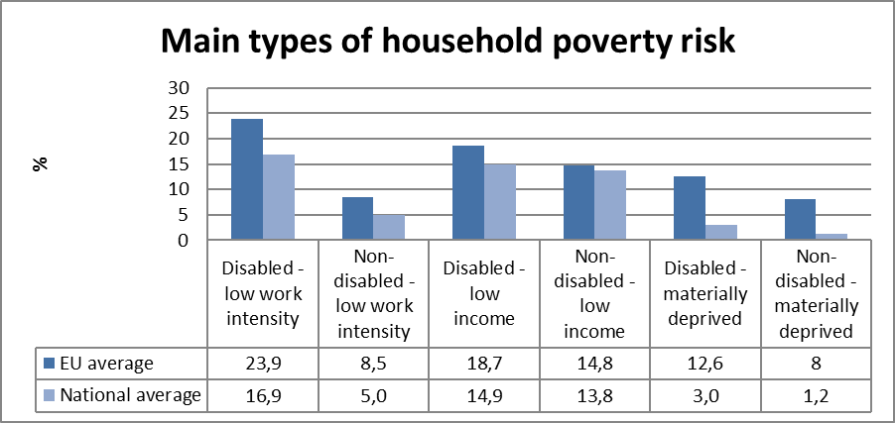
Source: EUSILC UDB 2013 – version 2 of August 2015

Table 18: People living in household poverty and exclusion by disability and gender (aged 16+)
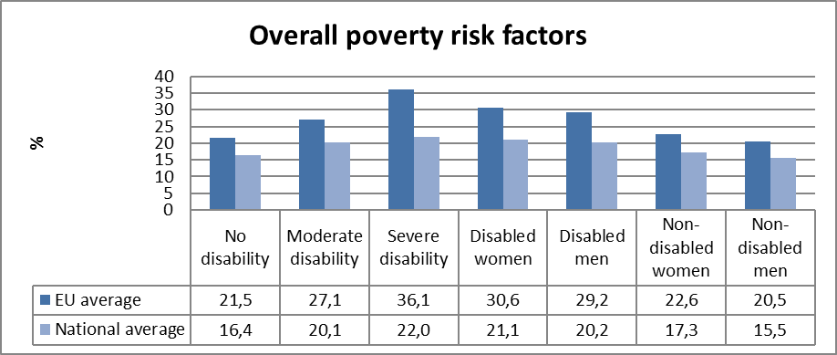
Source: EUSILC UDB 2013 – version 2 of August 2015

Table 19: Overall risk of household poverty or exclusion by disability and age (aged 16+)
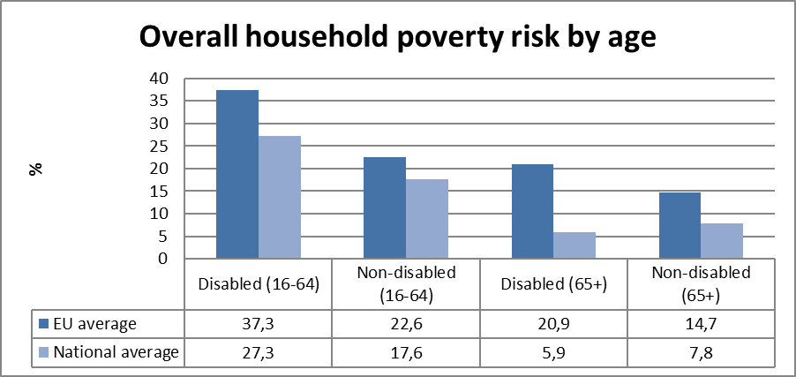
Source: EUSILC UDB 2013 – version 2 of August 2015

Table 20: Trends in household risk of poverty and exclusion by disability and age (EU-SILC 2013)
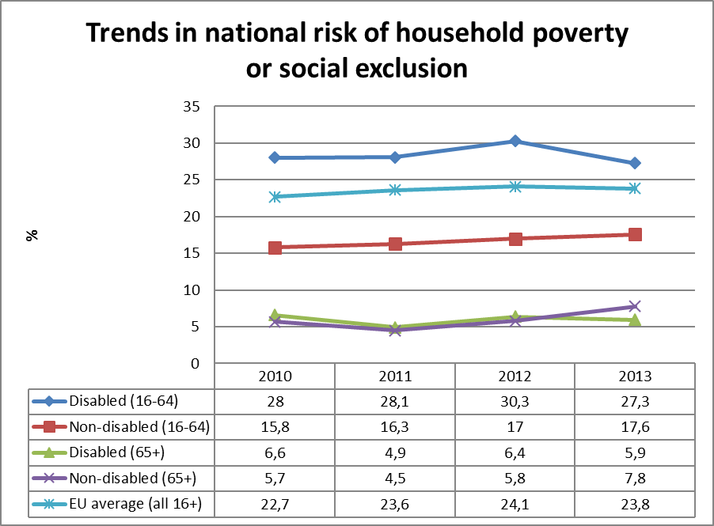
Source: EUSILC UDB 2013 – version 2 of August 2015 (and previous UDB)

Alternative data on disability and risk of poverty or social exclusion provided by the national expert:

Indicators of poverty and income inequality
 | 2010 | 2011 | 2012 | 2013 | 2014
At-risk-of-poverty rate (in %) | 14.5 | 13.6 | 15.1 | 15.9 | 16.4
Income quintile share ratio (S80/S20) | 4.1 | 4.0 | 4.1 | 4.6
Gini coefficient | 0.279 | 0.272 | 0.280 | 0.300
Source: Statec 2014; 2015 (in collaboration with CEPS/INSTEAD and EU-SILC).

In the absence of data about poverty risk referred to people with disabilities information can only be drawn on general population: In Luxembourg the poverty threshold in 2014 for a single person (le seuil de pauvreté pour une personne seule) corresponds at a monthly income of 1,639€. In 2015 this threshold rises up to 1.665€. The gap between the guaranteed minimum wage (1801.50€) and the threshold of poverty in 2014 was about 162.50€. In 2015 the gap between guaranteed minimum wage (1874€) and poverty threshold (1665€) increased to 209€. Poverty may get more visible and more social exclusion will follow.

Description of the situation and trends in relation to each target area

Employment

In general Luxembourg almost meet the EU 2020 employment target (75%) with a national quota at 72.8% in 2013. This is slightly less than the issued 73%. Employment rates of persons with disabilities in Luxembourg are quite above or on the same level as European average data. Persons with severe disabilities rank higher in employment activities than EU average due to the well-developed infrastructures for disabled worker and a widespread system of sheltered workshops.

Following the National Reform Programme of the Grand Duchy of Luxembourg under the European Semester 2015 (NRP), the government focuses primarily on accessing employment and integration into the mean labour market, as well as providing protected structures offering jobs to handicapped persons. The NRP mentions precisely some governmental measures supporting persons with specific needs:

An awareness rising event presenting good practices in employing persons with disabilities, the on-going dialogue with all entities to include companies, federations of companies, NGOs, etc. on improving employment of persons with disabilities in order to jointly implement solutions that are relevant to situations that are very dissimilar. Customized training and is becoming increasingly crucial for successful professional inclusion. At another level, the various job-coaching approaches that take into account specific circumstances of handicaps are seen as a complementary tool in supporting employers before, at the time of and after hiring a person who is officially recognised as disabled. However, the measures are not sufficient to stop rising unemployment of persons with disabilities. Statistical data show that more and more disabled worker don’t find a job; nor at the main labour market nor in a sheltered workshop. While the general population of unemployed persons rises by 31,8% (from13,535 up to 18,323) the population of unemployed worker with disabilities rises by 51,3% (from 870 up to 1,315). In other words for disabled worker the slope of unemployment was steeper than for non-disabled worker during the recent financial crisis. Disabled women do less likely participate in the labour market than disabled men. The participation of older workers with disabilities in the labour market remains very low compared to other age groups.

According to an inquiry submitted to the Ministry of Labour 2015 more than 92% of the employers do not meet the quotas to employ disabled worker. At the same time provider of sheltered workshops have long waiting lists so that to date more than thousand (1315) disabled worker are unemployed. Particularly young worker as soon as they leave the school are advised to sheltered workshops by the national employment agency. Placement rates from sheltered workshops into the first labour market are seldom reported. Strengthen requirements to get the approval and few job prospects may explain the continuously decline of the number of disabled worker. Some participants in sheltered workshops reported having had a number of difficult experiences at the main labour market as a disabled person.

Education

In relation to the national targets on education the government established in 2014 two priority development foci for education policy: keeping students in schools (reducing dropout) and improving academic success: In line to this objectives a number of measures are proposed that may also affect students with disabilities or learning problems; particularly to provide children and young people individualised support and guidance. New academic offers have been developed for students with difficulties and the existing offerings have been enlarged. Structures for students with behaviour difficulties or with severe behaviour disorders have been created.

A project on identifying students at risk of dropping out and providing individualised assistance has been launched in collaboration with the University of Luxembourg, to prevent students from dropping out. Looking on dropout data and inclusion indicators the measures do not seem to be enough to reach the national targets.

Aside from these considerations, the current situation is characterized by two trends which are difficult to bring together. One the one hand Luxembourg struggles for better PISA results, higher learning outcomes particularly in sciences and maths and at the same time the implementation of the CRPD particularly article 24 demands an inclusive education system for all learners including those with severe disabilities. Recent acts on school education (2009) introduced basic competence thresholds for all students starting in primary school. In accordance with the act on education 2009 inclusive education is priority and without having to make a specific request children with disabilities are admitted in mainstream education. All children with disabilities are provided with special support to reach the learning targets defined by the programme. But those children who do not succeed in reaching the learning thresholds within the maximum foreseen time risk to drop out or are referred to the special education system. The inclusion policy while retaining a competence based system of school promotion leads to high dropout rates and re-exclusion of prior included students. In addition the challenge for pupils in Luxembourg is intensified by the multilingualism of the national education system and it is hard for children with learning disorders to cope with. Overall the data do not reflect a general tendency to full inclusion of all children in mainstream education. Both, the number of children educated in special schools and the number of children with special needs included in mainstream are still rising. Furthermore, recently the number of early school leavers increases. In particular boys and children with migration background seem to be overrepresented in special education units.

A noticeable positive trend concerns students with special needs previously send to neighbouring countries: The number of these children is continuously decreasing since 2009.

The national target on participation in tertiary education (66%) is still far away from recent developments. In 2013 the national quota reached 42.8%. This is slightly above the EU target of 40% but an important gap compared with the national target of 66%. At the one and only national University the quota of students with disability is below 1%. The University founded in 2003 has now become a well-established institution in higher education in Luxembourg and provides for students who want to stay in the home country a broad spectrum of bachelor and master programmes. This has and will have in the future clearly a positive effect on higher education participation. Although the University moved to a new campus in 2015 the new infrastructures are still far away from universal design and a barrier free environment. There are still a lot of efforts to do in rising participation in higher education by including students with disabilities. Beyond the public university more and more private institutions offer fee based programmes in higher education in Luxembourg, so it is to be feared, that the admission to higher education will more and more depending on individual financial resources, all the more as national study grants have been cut in comparison to prior programmes.

Poverty and social inclusion

The national CRPD implementation report highlights in response to a risk of poverty and increased unemployment of persons with disabilities who don’t have access to paid employment at the main labour market and who have resources for an amount less than the income for severely disabled persons may also, under certain conditions, benefit from income for severely disabled persons. The legislator clearly stipulates that a disabled employee facing ordinary labour market cannot receive a salary that is lower than that resulting from the legal, regulatory or contractual provisions. Therefore, they cannot be subject to a deduction because of a disability.

In general the number of households at poverty risk has been raised over the last five years and disability is an important factor of poverty risk.
The new government programme 2013 mentions under the key word of "poverty”: The risk of poverty is higher among women than among men, for two reasons:-incomplete insurance careers for pensions and the wage gap. The Government will assist women to pursue a vocational activity or to maintain their individualized pension insurance career. Reorientation or professional reintegration projects for women, especially single-parent women, will be developed in the context of existing mechanisms in order to avoid that they slip into precarious situations, or even poverty.

Comparing households of persons with a disability and those without, the risk of poverty is higher for the first group in Luxembourg. Recent trends show a rising risk of poverty for people with disabilities. Particularly the risk of poverty emerges in the context of joblessness due to low educational attainment, which is often associated with disabilities. There are no census data about disability related income situation in Luxembourg available. The STATEC publications based on the national census (2011) illustrates some socio-demographic factors (e.g. women and single parent families) associated with the risk of poverty but no attention is paid to disability or long term illness.

The National Reform Programme draws attention to the need for close collaboration between the Ministry of Labour, Employment and the Social and Solidarity Economy and the Ministry of Family Affairs, Integration and the Greater Region to reduce poverty. The most important factor to react against poverty and social exclusion is seen as access to employment.

Between 20014 and 2015 the income gap between persons living at the risk of poverty and persons who benefit from the guaranteed minimum wage rises, thus poverty may get more visible and more social exclusion will follow.

Assessment of policies in place to meet the relevant headline targets

Employment

The National 2020 ”making it happen” report does not subtitle the three disability specific recommendations to specific measures: (L’ objectif national « emploi » (73% pour 2020) et « éducation » du Luxembourg (dérochage de <10% et enseignement supérieur de 66% en 2020) but list some measures which may be related to the above mentioned targets:

Employment:

- Youth unemployment: The Luxembourg Government introduced in June 2014 the “Youth Guarantee” programme (Project ‘guarantee for youth’, June 2014 -- Garantie pour la jeunesse)
- Project 'Job - Elo!' for low skilled youth
- Project 'Fit4Job’ - relaunch my career' (Relancer ma carrier)
- And other programmes:

“Organic measures”: reform of the national employment agency (ADEM)
measures targeting youth (see above) older workers, women, and measures supporting persons with special needs.

Reform of pensions (entered into force in 2013). (Réforme de l’assurance pension)

Abolition of the retirement solidarity (provide additional incentives to delay retirement age). (Suppression de la pré-retraite solidarité)

Draft law on the reform of the professional upgrading. (Projet de loi: la réforme du reclassement professionnel)

Draft law on introduction of a package of measures policy of the ages (April 2014) (Projet de loi portant introduction d’un paquet de mesures en matière de politiques des ages) recruitment of older workers, anticipation of the evolution of professional careers, improvement of working conditions, access to continuing training.

- In relation to measures supporting persons with special needs the CSR mentioned:

“Accessing employment and integration into the primary labour market, as well as providing protected structures offering jobs to handicapped persons is a priority to the government, since employment is a key factor for integrating such persons. This integration promotes autonomy and economic independence of these persons. In 2014, the government held an awareness event in which it presented good practices developed by companies in this area. The government is also conducting dialogue with all entities to include companies, federations of companies, NGOs, etc. in order to jointly implement solutions that are relevant to situations that are very dissimilar. Customized training is becoming increasingly crucial for successful professional inclusion. At another level, the various job-coaching approaches that take into account specific circumstances of handicaps are a complementary tool in supporting employers before, at the time of and after hiring a person who is officially recognised as disabled.” (p.25)

Following the NRP the national employment policy contains measures to promoting the employment of young people, women, older workers and persons with specific needs (e.g. better collaboration between the Ministry of Labour and Employment and the Ministry for Family affairs and Integration). In particular the procedures of reclassification outside a persons’ company has to be changed as this form of reclassification is not an attractive option to persons who know that they will lose their rights at the end of the new employment contract. A new specific status should be created for all persons undergoing professional reclassification either internally or externally, which would allow them to retain their rights as long as the disability from the previous job is in effect. The whole procedure should be made more transparent, uniform, and rapid.

The legal modifications to be implemented aim at improving the finding employees appropriate jobs while taking care not to prematurely exclude those who can work from the labour market.

The Ministry of Labour has started several programmes to reach the 73% employment criteria: Particularly youth unemployment is an important challenge in Luxembourg employment policy. Youth unemployment is more than three times higher than the overall unemployment rate. Therefore the government decided to adopt the EU programme called “Jugendgarantie” / “Garantie pour la jeunesse” (youth Guarantee). The programme issues at low skilled young people under 25 years of age to find a job, an additional training or to participate in internship within 4 months after leaving school or becoming unemployed.

Within the public employment agency (ADEM), an important reform is advancing to provide more individual guidance to jobseekers, which the Government intends to complete by the end of 2015. Additional staff has been hired and better training for ADEM employees is provided.
The announced measures on maternity and education allowances and the planned reform of parental leave can be expected in the perspective of the EU commission to contribute to increasing the labour market participation of women. Maternity and education leave can be used more flexible (in terms of time and child age) as before. Disincentives for second-earners to work arise from the ‘joint taxation’ system and from the design of the social benefit system.

The focus of most of the programmes and projects lies on making a person employable or attractive for the labour market. In times of crisis with reduced job offers this will only help those who are quit skilled and persons with disabilities drop out or fail in this competition. In this sense the hope to full inclusion at the labour market might not be very credible.

Education

The Luxembourg NRP highlights as key measures to achieve the national objectives on the two targets about education (dropout <10% and tertiary education > 66%):

- Providing (better) academic and professional guidance
- Diversifying and enlarging of language instruction
- Strengthen the ties between formal and informal education by incorporation of the childhood and youth department in the Ministry of Education.
- Creating an academic retention observatory to monitor early school leaving
- And other specific measures:

Draft Law for a review of vocational training (deposit early 2015), entered into force planned for the year 2015- (Projet de loi pour une révision de la formation professionnelle)

Initial vocational training reform: sought to match the qualifications requested at the labour market. (la réforme de la formation professionnelle initiale)

Project Balance sheet 2013 for the implementation of the reform of the primary education (Bilan de la mise en oeuvre de la réforme de l’école fondamentale)
Draft law on reform of secondary education (late 2013) (Projet de loi sur la réforme de l’enseignement secondaire).

The measures for achieving the national objective on tertiary education:

- Reform of the state financial aid schemes for higher education
- Expanding the offer of public and private higher education programmes
- Financial contributions for the University of Luxembourg
- Automatic mutual recognition of higher education diplomas from BENELUX countries.
- Strengthening the human capital base through adult education and training.

Reforms on vocational education and training and the secondary school reform to improve educational outcomes, in particular for those with a disadvantaged socioeconomic background, are still work in progress. Inclusion policy and measures to minimize school drop-out are not successful looking on statistical data.

Poverty and social inclusion

Poverty and social inclusion (social inclusion objective) involves:

- Continuing the policy of providing socio-educational welcoming structures to children
- Making beneficiary parents aware of the Guaranteed Minimum Income (GMI – RMG) mechanism for using welcome center checks (cheques repas).
- Increasing activation rates as parts of the GMI mechanism (increasing professional insertion)
- Promoting measures favouring the transition of young people from academic to professional life (motivating them to return to school)
- In particular the Guarantee for Youth promotes projects to.
- Develop an activation and information platform
- Activate Neet youth (not in education or training)
- Support inclusive volunteer programmes
- Neet Project supported by ESF targeting on persons 16-30 who removed from labour market and training

In addition, the social Aid act and the reform of the national dependency insurance (Réforme planifiée de l’assurance dépendance; soins de longue durée) is intended to provide better support to persons with chronic illness or dependency.

The social aid law was provided with 17million Euro, 50% furnished by state and 50% by the communes.

Finally the national strategy to counter homelessness and social exclusion linked to housing and the support actions of the Fund for European aid to the most deprived are mentioned.

Poverty and social inclusion are not expresis verbis mentioned in the National Programme in the context of disability. The targeted reduction by number of people seems to be difficult to evaluate as there are no such statistics compiled.

In general, higher levels of education are seen as a measure to improve employability and thus ensure increased employment rates that help reduce poverty. There are no data about “over-qualification” or unemployment due to over- qualification. The NRP mentions the promotion of social inclusion and the fight against poverty and emphasises the national equal rights action plan addressing socio-economic relations between men and women, including pilot projects and reforms in relation with early school leavers, but it is unclear to what extent people with disabilities are involved in these programmes.

To assess whether the measures in the 2015 NRP are credible, adequate and effective to meet the EU2020 targets on employment, education and poverty reduction from a disability perspective is hardly to accomplish.

Employment targets in general seem to be attainable as Luxembourg disposes of good economic data and the high frequency of commuters working in Luxembourg provide economic growth and prosperity. One big challenge however may remain: Disabled worker don’t have sufficiently access to the main labour market and there are even not enough jobs provided by sheltered Workshops (See data p.13). Politiques en faveur des personnes à besoins spécifiques (jobcoaching, accès au premier marché du travail et extension des structures protégées ...).

Dropout reduction issues may not be reached if coincidently inclusion will take place without changing the structures of the school system. As soon as the Luxembourg primary school insists on learning outcome thresholds children with disabilities will dropout from the mainstream. For so long as the school system will insist on the national multilingual approach (three national languages changing from early childhood to secondary education in frequency and importance from Luxembourgish, German and French, and in addition to the English Language) the drop out will be higher than in monolingual educational systems.

The reduction of at risk of poverty in the context of disability seems to be also a challenging issue. Disability is only mentioned in the NRP in the context of Social Security Medical Examinations (CMSS). Persons with disabilities may be guided more effectively toward the system that is best suited to an individual's situation. In this way, reviewing a professional reclassification, disability or certificate of fitness for work procedure more rapidly will avoid paying out long-term indemnities that occasionally extend to the end of benefits at 52 weeks because of excessively long case evaluation times. NRP, p.11).

Synergies between developments in the different areas

It is evident, that measures to advance the participation of persons with disabilities in education will facilitate later employment and social inclusion. Education is a key variable in inclusion. Tertiary education will be a key factor, too if primary and secondary education are of good quality and inclusive.

The lower employment in the main labour market of persons with disability is linked to higher risk to poverty and both may emerge from lower education. Thus all measures to higher education levels for persons with disabilities may help to reach the 2020 targets. The government renounces to penalize the non-compliance of employers to hire disabled worker (to fulfil the quota established by law). This may contrast to the announced inclusion policy. The approval procedure for disabled workers has been tightened by adding an obligation to participate at an information meeting at the national employment agency. Without participating at an informationworkshop (un atelier d'information obligatoire) no demand will be approved. The less disabled worker are officially recognised the more this problem will be marginalised or ignored.

Review of the European Semester from a disability perspective

Progress on disability-specific Country Specific Recommendations (CSRs)

The Council of the European Union recommends that Luxembourg take action in 2015 and 2016 to:

- Broaden the tax base, in particular on consumption, recurrent property taxation and environmental taxation.

- Close the gap between the statutory and effective retirement age, by limiting early retirement and by linking statutory retirement age to life expectancy.

- Reform the wage-setting system, in consultation with the social partners and in accordance with national practices, with a view to ensuring that wages evolve in line with productivity, in particular at sectorial level.

It’s hard to identify disability related actions within these three recommendations. If not even there is a real fear that the reforms of retirement will lead to a higher risk of poverty for persons with disabilities who cannot continue working till rising retirement age. Wage-settings in line with progress in productivity may increase strain and stress at the labour market for those who are not performing efficiently enough because of a disability. Binding productivity on income may lead to more inequity particularly in sheltered workshops. The more sheltered workshops are forced to run for productivity and economical success, the more severe disabled persons will drop out even from this protected labour market. One the other side skilled worker in sheltered workshops will get more and more essential for the workshops to maintain the thresholds of economic productivity and thus it will be against the economic interests of the work shop to send these skilled worker to the main labour market.

Progress on other CSRs from a disability perspective

There are no disability – related CSRs for Luxembourg on other CSRs found.

Assessment of disability issues in the Country Report (CR)

Within the CSR, the CR or other documents provided on the EU-Commission webpage, there was only one reference to “disability”:

“The government also intends to modernise the provisions regulating Social Security Medical Examinations (CMSS) in order to account for changes that have occurred on the legislative and practical levels since the establishment of this administration. These measures will provide better follow-up of long-term illnesses from the insurance viewpoint, in addition to making adjustments to the Employers' Mutual insurance fund and benefits in-kind mechanisms. By means of the reform, the Medical Inspection can guide persons more effectively toward the system that is best suited to an individual's situation. In this way, reviewing a professional reclassification, disability or certificate of fitness for work procedure more rapidly will avoid paying out long-term indemnities that occasionally extend to the end of benefits at 52 weeks because of excessively long case evaluation times.”

As mentioned above, from a disability viewpoint the three CSR do not promise progress in inclusion of persons with disabilities following the CRPD.

Assessment of the structural funds ESIF 2014-2020 or other relevant funds in relation to disability challenges

As highlighted in the NCR all projects developed and supported by Community finances under Structural Funds programmes must contribute to achieving Europe 2020 objectives.

There are four projects mentioned in the programme sheet under the partnership agreement of the Commission and Luxembourg, in relation to the objectives of this task:

Title: | Budget
“Promoting sustainable and quality employment and supporting labour mobility” | 10 830 259.96€
“promoting social inclusion combating poverty, and any discrimination” | 4 011 244.80€
“Investing in education, training and vocational training for skills and life long learning.” | 4 011 244.80€
Technical assistance | 1 203 373.44€

There is a national project on job-coaching financed by the Ministry of Health, the Ministry of Labour, and the European Social Fond: “job-coaching” – (service of the “association d’aide pour le travail thérapeutique pour personnes psychotiques”). The project issues on people with mental or psychiatric disorders in their endeavours for obtaining/maintaining a job. Following the self-description of the project it plays an active part on the employment of disabled persons (persons who are recognised and
registered as unemployed disabled worker at the national employment agency ADEM (Administration de l’Emploi). The project will end on 31st December 2015.

The following information is from the ESF web page for Luxembourg

The ESF investment focuses on the following areas:

The promotion of action to increase skills and knowledge among jobseekers, particularly those over the age of 45, in line with the future needs of the employment market, thus enhancing job market integration. Enhanced and sustainable job market integration for young people will also be targeted, particularly through the development and improvement of the implementation and monitoring of the Youth Guarantee.
Measures to reduce the overall unemployment rate, and particularly the youth unemployment rate, thus reinforcing social cohesion and inclusion. Concrete projects will be implemented to increase the engagement of marginalised people (who are alienated from the job market), particularly those receiving the guaranteed minimum income: job search support, training or other engagement measures to facilitate social inclusion.

Investing in education, training and vocational training for skills acquisition and life-long learning. The activities in this area aim to increase workers' skills and knowledge, particularly for those aged over 45, to increase employment rates for women and older people, and to improve the suitability of jobseekers' qualifications, including migrants.

The agreement indicates that the programmes issue on:

- tackling unemployment, in particular youth unemployment, by raising the qualifications and skills of the youth and job seekers with an immigration background and focusing on a better match between offer and demand in the labour market;
- reducing poverty through improved access to services and support to the social economy, including the integration of vulnerable minorities;
- enhancing equal access to lifelong learning to all age categories, in order, among others, to keep older worker longer in the work force.

Recommendations

Employment of persons with disability is doubtlessly an important target of the national policy and involves the collaboration of the economic sector, the enterprises and the public employers. If you are unemployed, disqualification periods are automatically imposed following an individual's decision to stop work voluntarily or on account of missing a 'signing on' appointment at the national employment agency. Cancelling the unemployment benefits will result. In Luxembourg employers who do not fulfil the legal requirement on employing persons with disabilities (the overwhelming majority), will not be requested on any compensatory payment or penalty, despite of the act on disability employment.

The Luxemburg legislation should be more strict and decisive that employers fulfil their obligations towards persons with disabilities.

Inclusive education without changing the national educational system lead by general standardised learning outcome measurements is paradox. This may result in more school dropout but didn’t open the way to educative inclusion. The act on primary education should provide more and flexible opening clauses for children who do not reach the fundamental learning thresholds.

The increase of higher education rates has to be in compliance with adequate employment offers including for persons with disabilities. There will be a risk of over qualification and academic unemployment particularly for academic with disabilities in the future if the employment market will not reflect the EU 2020 target including persons with disabilities.

http://ec.europa.eu/europe2020/pdf/targets_en.pdf 15.10.2015.
NRP , p.22. http://ec.europa.eu/europe2020/pdf/csr2015/nrp2015_luxembourg_en.pdf 15.10.2015.
NRP , p.22. http://ec.europa.eu/europe2020/pdf/csr2015/nrp2015_luxembourg_en.pdf 15.10.2015.
Objectifs Europe 2020: http://ec.europa.eu/europe2020/pdf/targets_fr.pdf 15.10.2015.
Ziele der Strategie „Europa 2020“:http://ec.europa.eu/europe2020/pdf/targets_de.pdf 15.10.2015.
Programme national de réforme du Grand-Duché de Luxembourg dans le cadre du semestre européen 2015 (Plan national pour une croissance intelligente, durable et inclusive Luxembourg 2020 Luxembourg, le 30 avril 2015). http://ec.europa.eu/europe2020/pdf/csr2015/nrp2015_luxembourg_fr.pdf 15.10.2015. http://ec.europa.eu/europe2020/pdf/csr2015/nrp2015_luxembourg_en.pdf.
EUSILC UDB 2013 – version 2 of August 2015.
The SILC survey questions are contained in the Minimum European Health Module (MEHM) http://epp.eurostat.ec.europa.eu/statistics_explained/index.php/Glossary:Minimum_European_Health_Module_(MEHM).
The methodology is further explained in the annual statistical reports of ANED, available at http://www.disability-europe.net/theme/statistical-indicators.
BINTENER, Chr. (MIFA/SNAS), BOURGEOIS, N. (Inter-Actions), FRISING, A. OSIER, G. REIFF, P. RIES, J. ZAHLEN, P. (STATEC) 2012 Rapport travail et cohésion sociale cahier économique N° 114.
See yearly report of the National Employment Development Agency (ADEM), 2014,p. 26 ) (http://www.adem.public.lu/fr/publications/adem/2014/rapport-annuel-succinct/ADEM_Rapport_Annuel_2014.pdf) 15.10.2015.
Figure based on date from the yearly reports of the ADEM (National Employment Development Agency) (http://www.adem.public.lu/fr/publications/adem/2014/rapport-annuel-succinct/ADEM_Rapport_Annuel_2014.pdf) 15.10.2015.
Figure based on date from the yearly reports of the ADEM (national Employment Development Agency) http://www.adem.public.lu/fr/publications/adem/2014/rapport-annuel-succinct/ADEM_Rapport_Annuel_2014.pdf) 15.10.2015.
Statec 2012 http://www.interlycees.lu/site/wp-content/uploads/2012/10/Statec-lu-Rapport-travail-et-cohesion-sociale-2012-FR-212p.pdf 22.10.2014.
Yearly rapport of the national Employment Development Agency / ADEM rapport annuel http://www.adem.public.lu/fr/publications/adem/2013/rapport-annuel-succinct/Adem_Rapport_Annuel_2013.pdf.
ADEM (National Employment Development Agency) ADEM rapport annuel http://www.adem.public.lu/fr/publications/adem/2013/rapport-annuel-succinct/Adem_Rapport_Annuel_2013.pdf (19.11.2014) computations by Limbach-Reich, A. 2015.
ADEM (National Employment Development Agency) ADEM rapport annuel http://www.adem.public.lu/fr/publications/adem/2013/rapport-annuel-succinct/Adem_Rapport_Annuel_2013.pdf (19.11.2014) computations by Limbach-Reich, A. 2015.
ADEM (National Employment Development Agency) rapport annuel http://www.adem.public.lu/fr/publications/adem/2013/rapport-annuel-succinct/Adem_Rapport_Annuel_2013.pdf (19.11.2014) computations by Limbach-Reich, A. 2015.
STATEC (2015) http://www.statistiques.public.lu/stat/ReportFolders/ReportFolder.aspx?IF_Language=eng&MainTheme=2&FldrName=3&RFPath=92 15.10.2015.
Joel Delveau (2015). OGBL Service salarié handicape 08.10.2015 (personal communication).
Databasis: yearly reports of the national Ministry of Labour. http://www.mte.public.lu/ministere/rapports-activite/rapport_act_2014.pdf (15.10.2015).
STATEC (2015) http://www.statistiques.public.lu/stat/ReportFolders/ReportFolder.aspx?IF_Language=eng&MainTheme=2&FldrName=3&RFPath=92 15.10.2015.
For the LFS AHM data see, Early school leavers http://appsso.eurostat.ec.europa.eu/nui/show.do?dataset=hlth_de010&lang=en and tertiary educational attainment http://appsso.eurostat.ec.europa.eu/nui/show.do?dataset=hlth_de020&lang=en.
Ministry of Education (Ministère de l’éducation et formation nationale) http://www.men.public.lu/catalogue-publications/secondaire/statistiques-analyses/decrochage-scolaire/decrochage-12-13/fr.pdf (15.10.2015).
This theoretical dropout rates are based on pupils just before the end of compulsive school age attending (or dropping out from) regular schools. (Ministry of Education 2014. Education in numbers and dropout (Le décrochage scolaire au LuxembourgParcours et caractéristiques des jeunes en rupture scolaire Causes du décrochage année scolaire 2012/2013 http://www.men.public.lu/catalogue-publications/secondaire/statistiques-analyses/decrochage-scolaire/decrochage-12-13/fr.pdf (15.10.2015).
The graph is built by data derived from yearly reports of the Ministry of Education and Training http://www.men.public.lu/fr/publications/systeme-educatif/rapports-activites-ministere/index.html.
Public schools, private schools not included.
Students in special education programmes age < 16.
Female students in special educational needs programmes (éducation différenciée).
Male students in special educational needs programmes.
Students with special needs educated outside of Luxembourg.
Students with special needs educated outside of Luxembourg.
Students with special needs included in mainstream classes.
2
Data based on communications of the student secretary (SEVE) of Luxembourg University compiled by the author and will by published in: Clemens Dannenbeck/Carmen Dorrance/Anna Moldenhauer/Andreas Oehme/Andrea Platte (Hrsg.) Inklusive Hochschule. Ansätze – Perspektiven – Kritik. Bad Heilbrunn: Klinkhardt. (in press).
Statec (2015) Luxembourg in figures 2015 http://www.statistiques.public.lu/catalogue-publications/luxembourg-en-chiffres/luxembourg-figures.pdf (15.10.2015).
Statec (2015) Cahier économique N° 120 Rapport travail et cohésion sociale. http://www.statistiques.public.lu/fr/publications/series/cahiers-economiques/2015/120-cohesion-sociale/index.html (15.10.2015).
Parliamentary question 30.July, 2015 http://www.ccdh.public.lu/fr/archives/2015/QP-1333.pdf.
Application procedure « handicaped worker » (salarié handicapé) only in German or French accessible : http://www.guichet.public.lu/citoyens/fr/travail-emploi/salarie-handicape/statut-salarie-handicape/reconnaissance-statut-salarie-handicape/ (04.11.2015).
Dondelinger, N. (2013) Die Empfindungen von Menschen mit einer psychischen Erkrankung gegenüber dem ersten Arbeitsmarkt am Beisiel des Haff Ditgesbaach. BA-Thesis University of Luxembourg.
Act on fondamental education in Luxembourg / Loi du 06. Fevrier 2009 relative à l’obligation scolaire et portant organisation de l’enseignement fondamental. http://www.legilux.public.lu/leg/a/archives/2009/0020/a020.pdf#page=4 (03.11.2015).
See L’essentiel 17.08.2015 http://www.lessentiel.lu/fr/news/luxembourg/story/10763475.
Act on grants in higher education (Loi du 24 juillet 2014 concernant l’aide financière de l’Etat pour études supérieures) http://www.cedies.public.lu/fr/legislation/Loi-du-24-juillet-2014.pdf (03.11.2015).
Article 13 of the act on disabled worker (Art. 13. « Le salaire du «salarié» handicapé ne peut être inférieur à celui qui résulte de l'application des dispositions légales, régle- mentaires ou conventionnelles. ») http://www.legilux.public.lu/leg/textescoordonnes/compilation/code_administratif/VOL_7/CAT_SPEC_EMPL/TRAVAILLEURS_HANDI.pdf (15.10.2015).
The programme of the new government (programme gouvernemental) 2013 (p.134). http://www.gouvernement.lu/3322796/Programme-gouvernemental.pdf (03.11.2015).
See EUSILC UDB 2013 – version 2 of August 2015 (p. 22 of this report) (03.11.2015).
National plan for smart, sustainable and inclusive growth Luxembourg 2020. http://ec.europa.eu/europe2020/making-it-happen/country-specific-recommendations/index_en.htm (15.11.2015).
The Youth Guarantee is a new approach to tackling youth unemployment which ensures that all young people under 25 – whether registered with employment services or not – get a good-quality, concrete offer within 4 months of them leaving formal education or becoming unemployed. The good-quality offer should be for a job, apprenticeship, traineeship, or continued education and be adapted to each individual need and situation. EU countries endorsed the principle of the Youth Guarantee in April 2013 (EU- Commission 22.04.2013) http://ec.europa.eu/social/main.jsp?catId=1079&langId=en (10.10.2015).
The draft versions of the acts are published at : Guichet public http://www.guichet.public.lu/citoyens/fr/actualites/2015/04/29-reforme-conge-parental/index.html. (03.11.2014).
EU Commission (2015) Recommendation on the 2015 National Reform Programme of Luxembourg and delivering a Council opinion on the 2015 Stability Programme of Luxembourg (15.05.2015) http://ec.europa.eu/europe2020/pdf/csr2015/csr2015_luxembourg_en.pdf (15.10.2015).
The Abbreviation of the NRP (National Reform Program) in French is PNR: Programme national de réforme 2015.
EU-Commission (2015) Recommendation on the 2015 National Reform Programme of Luxembourg and delivering a Council opinion on the 2015 Stability Programme of Luxembourg (15.05.2015) http://ec.europa.eu/europe2020/pdf/csr2015/csr2015_luxembourg_en.pdf (15.10.2015).
Act on social aid / loi du 18 septembre 2009 organisant aide sociale (http://www.legilux.public.lu/leg/a/archives/2009/0260/a260.pdf#page=2 (03.11.2015).
The Abbreviation of the NRP (National Reform Program) in French is PNR: Programme national de réforme 2015.
Press release of the Ministry of Economy and Trade http://www.odc.public.lu/actualites/2011/04/PNR_Luxembourg_2020/PNR_Luxembourg_2020_presentation.pdf (03.11.2015).
Office national (« guichet.Lu) http://www.guichet.public.lu/citoyens/de/travail-emploi/salarie-handicape/statut-salarie-handicape/reconnaissance-statut-salarie-handicape/index.html (21.11.2015).
http://ec.europa.eu/europe2020/pdf/csr2015/nrp2015_luxembourg_en.pdf.
The Budget information are avalable at http://ec.europa.eu/esf/main.jsp?catId=67&langId=en&newsId=8408 (23.11.2015).
A description of the project is available at http://www.jobcoaching.lu/?page_id=17 (23.11.2015).
THE ESF IN LUXEMBOURG http://ec.europa.eu/esf/main.jsp?catId=576&langId=en&pay=LU (23.11.2015).
European Commission Summary of the Partnership Agreement for Luxembourg 2014-2020 http://ec.europa.eu/contracts_grants/pa/partnership-agreement-luxembourg-summary_en.pdf (23.11.2015).
Act on disabled worker 2003 (Loi du 12 septembre 2003 relative aux personnes) handicapées http://www.legilux.public.lu/leg/textescoordonnes/compilation/code_administratif/VOL_7/CAT_SPEC_EMPL/TRAVAILLEURS_HANDI.pdf (23.11.2015).
Parliamentary question 30.July, 2015 http://www.ccdh.public.lu/fr/archives/2015/QP-1333.pdf.
Act on primary Education in Luxembourg / Loi du 06. Fevrier 2009 relative à l’obligation scolaire et portant organisation de l’enseignement fondamental http://www.legilux.public.lu/leg/a/archives/2009/0020/a020.pdf#page=4 (03.11.2015).
N
O
I

